# Design Overview for Tank Game <<Updated>>

Name: Ngo Cong Thanh

Student ID: 103433609

# Summary of Program

My program that I intend to do is inspired by the “Tank” game from 1990s. It is a game that have single player game that allow user control a tank and fight with bot tanks that program produce. The game will divide into two level, hard and easy. Depend on the difficulty, the map will generate bot that appropriate in this stage. Player will completely win if player can destroy all enemy tanks.

There will be 2 players mode that allow the second player can join. Two players will control their tank through same keyboard. First player use arrows button, the second use “a, d, s, w”. They will help each other to finish the game

Include a sketch of sample output to illustrate your idea.

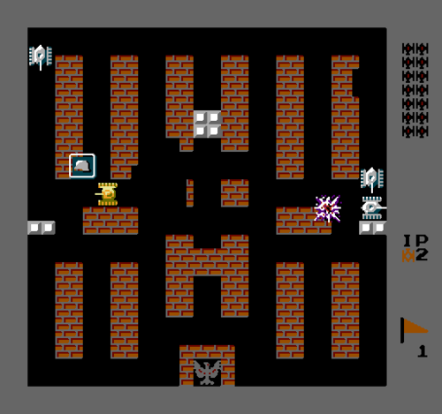

# Required Roles

Describe each of the classes and interfaces you will create using the following table (one per record).

Table : <<role name>> details

|  |  |  |
| --- | --- | --- |
| Responsibility | Type Details | Notes |
| Tank | Size, direction, hitpoint, point, img , shoot, speed | Form up tank |
| PlayerTank | Hitpoint, img, speed | Inherit from Tank object |
| Bot | CanMove, StepCount |  |
| EasyBots | Position, size, direction, img, hitpoint |  |
| HardBots | Position, size, direction, img, hitpoint |  |
| MediumBots | Position, size, direction, img, hitpoint |  |
| Map | Elements, position, size, Stone, Metal | Abstract class |
| Stage1 | Modified map, arrange elements |  |
| Stage2 | Modified map, arrange elements |  |
| Stage 3 | Modified map, arrange elements |  |
| Bullet | Size, Come from tank | Bot automatic fire mode. |
| GameModel | Game mechanic, set difficulty, binding moving console. |  |
|  |  |  |
|  |  |  |

Table 2: Direction details

|  |  |
| --- | --- |
| Value | Notes |
| North | Angel: 0 |
| South | Angle 180 |
| West | Angle: 270 |
| East | Angle: 90 |
|  |  |

Table 3: Difficulty details

|  |  |  |
| --- | --- | --- |
| Value | | Notes |
| Easy | Numbers of bots, how bots and player spawn | |
| Medium | Numbers of bots, how bots and player spawn | |
| Hard | Numbers of bots, how bots and player spawn | |